Research Report
Martin Grigorov - 3476596
Dimitar Ivanov - 3476529

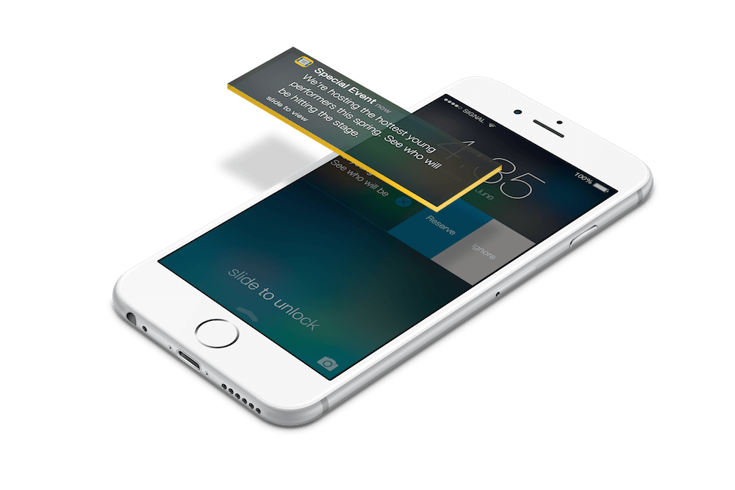

Main question 3
Hypothesis 3
Summary of sub-questions 3
Research goal 3
Methods 3
Literature Study 3
Community Research 3
Interview 3
Observation 3
Elaboration per sub-question 4
Conclusion and recommendations 4
Source references 5
Reflection 5

Main question
How push notifications can be used to affect the life of users in a positive way?

Summary of sub-questions
- What is a push notification?
- What is the purpose of push notifications?
- What is the technology used in push notifications?
- What is the advantage of using push notifications?
- What is the disadvantage of using push notifications?
- What makes users disable push notifications?
- What push notifications users prefer?
- Which data will be used for notifications?
- What is the right way to ask for permission for push notifications?

Research goal
The goal of this research is to find the best way to use push notifications to motivate and encourage elderly people to be more active and maintain a healthier lifestyle.

Methods

Best good and bad practices
Inventive research was done using the Google Scholar and other web engines in the field of UI Design and Health in older adults. These findings were used to develop a prototype.

Design pattern research
Inventive research was done using the Google Scholar and other web engines in the field of UI Design and Health in older adults. These findings were used to develop a prototype.

Explore user requirements
Get a detailed view of how users will be using your solution and what their requirements are. How Talk to your clients about their expectations and describe how the different users (or stakeholders) will interact with the system under development. It is highly recommended that you directly involve end users, rather than just the client.

Problem analysis
Before solving a problem, it is important to understand it. Moreover, problem analysis ensures that you are not solving the wrong problem.

Hardware validation
Hardware does not always perform according to its specifications. Hardware validation ensures that the hardware performs as expected and excludes hardware as a source of errors.

Non-functional test
Non-functional tests will be conducted to determine if our product is suitable for the target audience we have.

Prototyping
Develop a functional prototype to prove the importance and possibilities of our research.

Observation
Observations were done by members of our group. During the interviews with the adults in the elderly age group, our team members observed which devices these adults owned.

Elaboration per sub-question
- What is a push notification?
A push notification is a message that pops up on a mobile device. App publishers can send them at any time, users don’t have to be in the app or using their devices to receive them. They can do a lot of things, for example, they can show the latest sports scores, get a user to take an action, such as downloading a coupon, or let a user know about an event, such as a flash sale. Push notifications only reach users who have installed your app. _{[1]}

- What is the purpose of push notifications?
Push notifications provide convenience and value to app users. For example, users can receive:

- Simple tasks to perform around the house.
- Reminders to do exercises.
- Suggestions regarding their health.

For app publishers, push notifications are a way to speak directly to a user. They don’t get caught in spam filters or forgotten in an inbox — click-through rates can be twice as high as email. They can also remind users to use an app, whether the app is open or not. They can also be used to drive actions, such as:

- Promoting products or offers to increase sales
- Improving customer experience
- Driving users to other marketing channels, such as social networks _{[1]}

- What is the technology used in push notifications?
A push notification is a message that is "pushed" from backend server or application to user interface, e.g. (but not limited to) mobile applications and desktop applications. Push notifications were first introduced by Apple in 2009. Push notifications are mainly divided into 2 approaches, local notifications and remote notifications. For local notifications, the application schedules the notification with the local device's OS, or, alternatively, sets as a timer in the application itself if it is able to continuously run in the background. When the event's scheduled time is reached, or the event's programmed condition is met, the message is displayed in the application's user interface. Remote notifications are handled by a remote server. Under this scenario, the client application needs to be registered on the server with a unique key (e.g., a UUID). The server then fires the message against the unique key to deliver the message to the client application via an agreed client/server protocol such as HTTP or XMPP and the client displays the message received. When the push notification arrives, it can transmit short notifications and messages, set badges on application icons or play alert sounds to attract user's attention. Push notifications are usually used by applications to bring information to users' attention._{[2]}

- What is the advantage of using push notifications?
Grab customers attention.
Reach your customers no matter what they are doing. Since they can reach beyond your digital presence, they are good for re-engagement campaigns.
Urgent messages. If you really need to reach a user, a push may be the best way to do it._{[3]}

- What is the disadvantage of using push notifications?
Not everyone opts in for push notifications. Customers have to agree to
receive them. On Android, apps are not required to ask permission to send
push notifications. iOS apps require a user to grant permission for an app to
send them push notifications.
If push notifications play a critical role in getting your users to form a habit of
using your app, declining access could lead to losing them forever.
It is easy for the user to opt out and consider this, it’s even easier for them to
uninstall the app.
They are not good to educate customers on how to use your app or to let
them know about an update.
Not everyone responds the same way to different messaging channels.
Sending too many push notifications can trigger uninstalls. 78% of customers
will uninstall an app if they are not happy with the push notifications
they receive._{[3]}

- What makes users disable push notifications?
Because they are annoying

- 52% of app users say that push notifications are an annoying distraction.
- However, 26% of users said that they were grateful for push notifications because they get alerts about their interests.
- Another 20% of app users stated that notifications enhance productivity. They are able to receive important and timely information without having to launch the app because of push notifications.

So, it’s clear that the opinions are split about this subject. However, the fact that over 50% of users find them annoying.
The question now changes to, “why are they so annoying?”

Marketers are most responsible for this problem. Marketers overuse push notifications. Marketers believe that the users will be so excited about any communication from the app. But this is obviously not the case. Sending too many push notifications can cause your users to stop using your app altogether._{[4]}

- What push notifications users prefer?

- Messages that make their life easier
- Messages that include a special offer based on their location
- Messages that alert them about things that really matter to them
- Messages that help them pick up where they left off
- Messages that keep them posted _{[3]}

- Which data will be used for notifications?
Time of the day, time zone, app user preferences - at what time of the day your user tend to visit your app, the content of push must be relevant and tie into a specific time of day or a triggered event, user schedule and engagement window.
The only way to get the timing right is by looking at customer data. Customer data is essential to identify each user’s unique engagement window.
In consideration should be the length of the message. The amount of words that appear on your screen varies from one smartphone to another. Shorter messages are usually more effective.
According to Localytics data, notifications with 10 words or fewer see almost double the click rate than those with 11–20 words.
Personalization - using the user’s first name is just the first step to take. In your notifications, you should showcase all you know about the user. Send notifications based on user’s past search history, location and available personal data.
Use their phone’s system language, or their explicit language preference rather than making an assumption based on their country.
Make sure that when users tap a push they get where they are supposed to go. Don’t send them to a generic home screen, send them to a specific page or the product they want to see.
One solution for this is to deep link directly from push notifications to relevant in-app pages or sections._{[3]}

- What is the right way to ask for permission for push notifications?
iOS apps require a user to grant permission for an app to send them push notifications. Convincing users to opt-in is important for the success of apps. The majority of iOS apps show a standard iOS alert when the app is first opened. Instead of asking right away to opt-in for push notifications, prepare them by using in-app messages to explain why you want to send them push notifications and how exactly enabling push will benefit them. With a comprehensive user onboarding strategy, you can influence user opt-in rates. Since you can only trigger Apple’s default permission request once per feature, some apps use priming for push before the actual Apple permission request screen appears. This is the process you need to follow: First, choose the right moment. Good moments can be when there’s a compelling need that push notifications can address. Once you have identified the right moments, explain the value. Users should see clearly and quickly the benefits they get from receiving push notifications. In-app messages work very well to explain how users can get the most out of your app or website. When asking them to opt-in don’t use Apple’s generic opt-in prompt, create a custom one where you explain the value of enabling push and ask the users if they want to receive notifications. If the user says YES, then trigger the generic Apple prompt. If the user says NO, you still have the ability to ask them again sometime in the near future. So, delay the Apple prompt until the user comes to a screen that needs them to grant access. It’s important to ask them when the time is right which may vary according to the type of app. But never ask as soon as the user is onboarding the app because it’s too early. You need to gain the user’s trust before asking for permissions. A study done by Localytics shows that users completing between 1 and 3 sessions in an app have an average opt-in rate of 35% and the rate doubles when users complete 4–6 sessions in an app. _{[3]}

Conclusion and recommendations
End goal should be to create push notifications that don’t feel like an annoyance. Keep them purposeful and valuable to the user. Here are a few key takeaways:
- The number one reason why people uninstall mobile apps is annoying push notifications.
- There are three elements that make up an effective message: the call to action, personalization, and its level of intrigue.
- Instead of sending notifications at random times, consider when the user would want to receive them.
- Keep notifications silent, don’t use vibration.
- Emojis lead to 85% higher push open rates.
- Include images when relevant.
- Keep text under 24 characters.
- Well-timed to be effective.
- Intriguing question or comment, almost guarantees user engagement

Source references
- Airship Explainer. Push Notifications Explained. Retrieved on December 5, 2019 from https://www.airship.com
- Wikipedia. Push technology. Push notifications. Retrieved on December 5, 2019 from https://wikipedia.org
- O. Sentrec. Creating push notifications that are timely, personal and actionable. Retrieved on December 5, 2019 from https://medium.com/
- Ian Blair - Why users mute push notifications. Retrieved on December 5, 2019 from https://buildfire.com

Reflection
Doing this research, I learned the different aspect that has to be taken into consideration when designing and implementing push notifications, especially for older adults. I also gained more in-depth knowledge of research methods and how they can be applied.
Martin

This was my first time doing a proper research. I learned how to make the questions for the proposal and how to implement the methodologies when doing the report. The topic of our research made me understand that notifications should be strict, intriguing, interesting and most importantly not annoying.
Dimitar

